Chapter 2 p.40

Two-year comparison of top 10 most attacked regions

Grouped bar graph showing Two-year comparison of top 10 most attacked regions. X-axis represents regions United States, Europe, East Asia, Korea, India, Others, South East Asia, Australia, United Kingdom, Japan, Germany, and y-axis represents percentages from 0 to 60% in intervals of 10%. In FY22 United States shows highest percentage of 45%, followed by India with 25%, and the lowest is seen in Korea and Germany with 3%. In FY23 United States shows highest percentage of 55%, followed by Europe with 15% and the lowest percentage is seen in Germany with 3%. All the values are approximated.

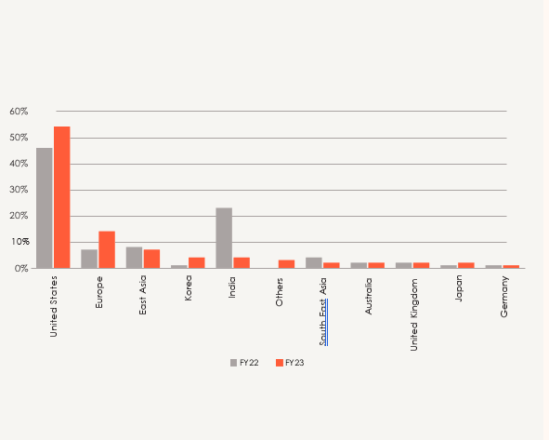

Source: Microsoft Global DDoS Mitigation Operations